
Ministry of Agriculture, Food and Rural Affairs | Ministère de l’Agriculture,  de l’Alimentation et  des Affaires rurales
581 Huron Street  Stratford, ON N5A 5T8  Tel: 519 271-0280  Fax: 519 273-5278 | 581 rue Huron  Stratford (Ontario) N5A 5T8  Tél. : 519 271-0280  Téléc. : 519 273-5278

Agriculture Development Branch

November 22, 2010

The Ernest C. Manning Awards Foundation
Box 2850
Calgary
AB
T2P 2S5

To Whom This May Concern;

I am writing in support of Ivan Milin, President and CEO of EcoSpace Engineering Ltd. and his innovative Milinator process. I have had the opportunity to work with Ivan in an advisory role over the last few years as he pursued his vision to bring this very innovative and ingenious technology to fruition, as a viable and environmentally responsible alternative for processing livestock manure.

The process is a very unique, original and futuristic way of transforming a waste product (manure) into an organic fertilizer and potentially as well, into a feed ingredient. The process captures and ties up nutrients such as nitrogen which are later released for plant growth when applied to the soil as a fertilizer. This reduces the risk of nitrogen escaping into the environment, where it can negatively affect the air quality as well as water quality. Ivan has given careful thought to how the process can be adapted to the manure systems of livestock barns, requiring little in the way of energy, rather, relying on the natural processes of the flies to convert the manure to nutrient rich fertilizer in the relatively short period of 4-5 days. This rapid conversion is beneficial in reducing the intensity of odours that can otherwise emanate from a livestock operation.

The potential for commercializing this innovative process for use in situations in addition to use on manure is very promising. I look forward to providing continued support and guidance to Ivan, when and where possible on his journey to success and satisfaction with his Milinator technology.

Sincerely,

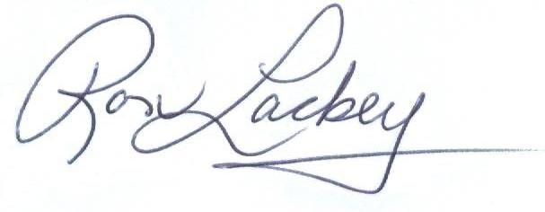

Ron Lackey
Feed Ingredients and Byproducts Feeding Specialist

